 | Geometry Nodes Editor - Header - Add Modifier Menu - Hair - Deformation modifiers
Table of content
Detailed table of content 1
Hair - Deformation modifiers 4
General functionality 4
Blend Hair Curves 5
Frizz Hair Curves 5
Hair Curves Noise 6
Roll Hair Curves 7
Rotate Hair Curves 8
Shrinkwrap Hair Curves 9
Smooth Hair Curves 9
Straighten Hair Curves 10
Trim Hair Curves 10

Detailed table of content
Table of content
Detailed table of content 1
Hair - Deformation modifiers 4
General functionality 4
Output Attributes 4
Internal Dependencies 5
Bake 5
Named Attributes 5
Blend Hair Curves 5
Factor 5
Blend Radius 5
Blend Neighbours 5
Preserve Length 5
Internal Dependencies 5
Named Attribute 5
Frizz Hair Curves 5
Factor 5
Distance 5
Shape 6
Seed 6
Preserve Length 6
Output Attributes 6
Offset Vector 6
Hair Curves Noise 6
Factor 6
Distance 6
Shape 6
Scale 6
Scale along Curve 6
Offset per curve 6
Seed 6
Preserve Length 7
Output Attributes 7
Offset Vector 7
Roll Hair Curves 7
Factor 7
Subdivision 7
Variation Level 7
Roll Lenght 7
Roll Radius 7
Roll Depth 7
Roll Taper 7
Retain Overall Shape 7
Roll Direction 7
Random Orientation 8
Seed 8
Preserve Length 8
Internal Dependencies 8
Named Attribute 8
Rotate Hair Curves 8
Factor 8
Axis 8
Angle 8
Random Off 8
Lock Ends 8
Seed 8
Shrinkwrap Hair Curves 9
Surface 9
Surface Object 9
Factor 9
Offset Distance 9
Above Surface 9
Smoothing Steps 9
Lock Roots 9
Smooth Hair Curves 9
Amount 9
Shape 9
Iterations 9
Weight 10
Lock Tip 10
Preserve Length 10
Straighten Hair Curves 10
Amount 10
Shape 10
Preserve Length 10
Trim Hair Curves 10
Scale Uniform 10
Length Factor 10
Replace Length 10
Length 10
Mask 11
Random Offset 11
Pin at parameter 11
Seed 11
Output 11
Geometry 11

Hair - Deformation modifiers

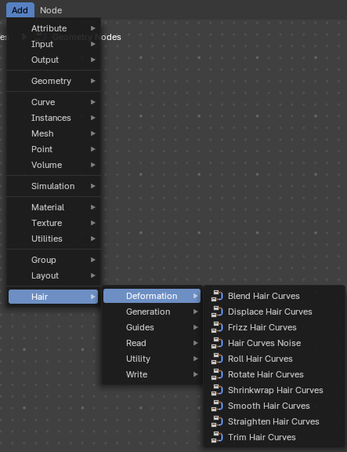
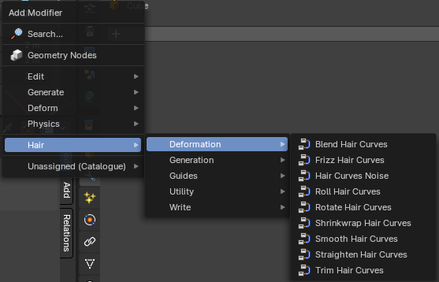

Hair nodes are Geometry node groups found in the Essentials Library included with Bforartists. They differ from the other nodes in the add menu due to being mid level node groups instead of individual low level nodes.
These hair nodes are also available as Modifiers. And this modifier adds the same node group as you would do it in the geometry node editor. Which means you can control these node groups in the modifier stack now instead of the geometry node editor.
Note that hair curves is usually a mesh only functionality. But shows for all other object types too.


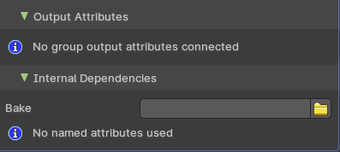
General functionality
All Hair nodes have an Output Attributes and Internal dependencies tab. If the hair node has output attributes or internal dependencies depends of the hair node.

Output Attributes
Contains group output attributes in case the node group has any. It is usually the output of the nodes besides the geometry.

Internal Dependencies

Bake
Define a bake name and a bake folder.
TODO: find out how this is meant to work.

Named Attributes
Named attributes of the hair node group in case the group has any.

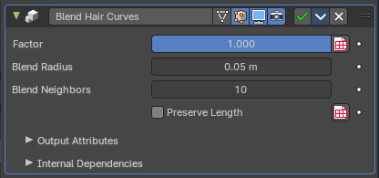
Blend Hair Curves
Blends the shape between multiple hair curves in a certain radius together.

Factor
Factor to blend overall effect.

Blend Radius
Radius to select neighbors for blending.

Blend Neighbours
Amount of neighbors used for blending.

Preserve Length
Preserve the length of each curve during deformation.

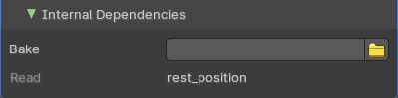
Internal Dependencies

Named Attribute
Read attribute with name rest_position

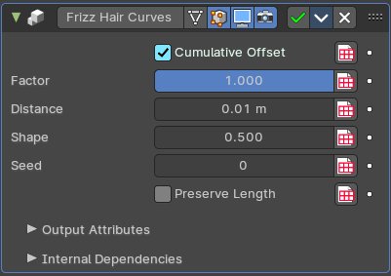
Frizz Hair Curves
Deforms hair curves using a random vector per point to frizz them.

Factor
Factor to blend overall effect.

Distance
Overall distance factor for the deformation.

Shape
Shape of the influence along curves. 0 means constant. 0.5 means linear.

Seed
Random seed for the operation.

Preserve Length
Preserve the length of each curve during deformation.

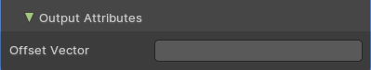
Output Attributes

Offset Vector
The vector by which each point was offset during deformation.

Hair Curves Noise
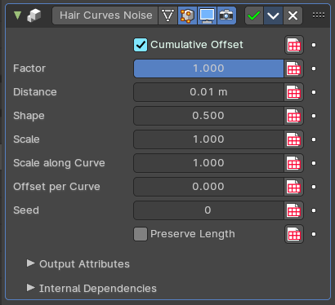
Deforms hair curves using noise texture.

Factor
Factor to blend overall effect.

Distance
Overall distance factor for the deformation.

Shape
Shape of the influence along curves. 0 means constant. 0.5 means linear.

Scale
Scale of the noise texture by root position.

Scale along Curve
Scale of the noise texture along the curve.

Offset per curve
The offset per curve.

Seed
Random seed for the operation.

Preserve Length
Preserve the length of each curve during deformation.

Output Attributes

Offset Vector
The vector by which each point was offset during deformation.

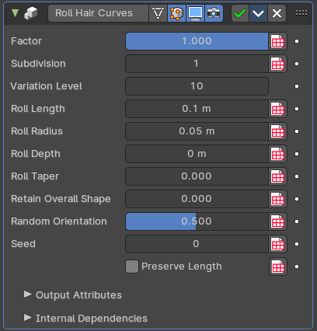
Roll Hair Curves
Rolls up hair curves, starting from their tips.

Factor
Factor to blend overall effect.

Subdivision
Subdivision level applied before deformation.

Variation Level
Level of smoothing on the roll path to include shape variation.

Roll Lenght
Length of each curve to be rolled

Roll Radius
Radius of the rolls.

Roll Depth
Depth offset of the rolls.

Roll Taper
Taper of the roll.

Retain Overall Shape
Offset the roll along the original curve to retain shape.

Roll Direction
The axis around each curve is rolled.

Random Orientation
Amount of randomization of the direction of the roll.

Seed
Random seed for the operation.

Preserve Length
Preserve the length of each curve during deformation.

Internal Dependencies

Named Attribute
Read attribute with name rest_position

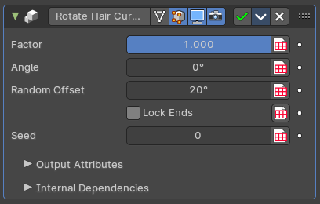
Rotate Hair Curves
Rotates each hair curve around an axis.

Factor
Factor to blend overall effect.

Axis
Rotation Axis. The default is tangent at root.

Angle
Angle of rotation

Random Off
Random offset to the rotation angle per curve.

Lock Ends
Lock rotation to the axis between the curve ends.

Seed
Random seed for the operation.

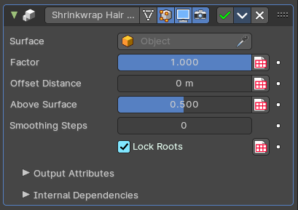
Shrinkwrap Hair Curves
Shrinkwrap hair curves to a mesh surface from below and optionally from above.

Surface
Surface geometry used for shrinkwrap.

Surface Object
A surface object used for shrinkwrap.

Factor
Factor to blend overall effect.

Offset Distance
Distance of the surface to shrinkwrap.

Above Surface
Blend shrinkwrap for points above the surface.

Smoothing Steps
The steps of Smoothing applied after shrinkwrap.

Lock Roots
Lock the position of root points.

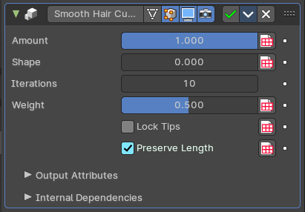
Smooth Hair Curves
Smoothes the shape of hair curves.

Amount
Amount of smoothing.

Shape
Shape of the influence along curves. 0 means constant. 0.5 means linear.

Iterations
Amount of smoothing steps.

Weight
Smoothing weight.

Lock Tip
Lock the position of tip points.

Preserve Length
Preserve the length of each curve during deformation.

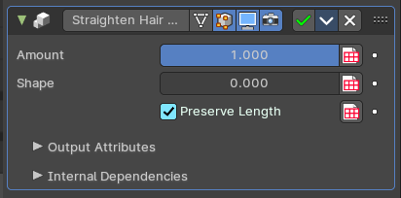
Straighten Hair Curves
Straighten hair curves between root and tip.

Amount
Amount of smoothing.

Shape
Shape of the influence along curves. 0 means constant. 0.5 means linear.

Preserve Length
Preserve the length of each curve during deformation.

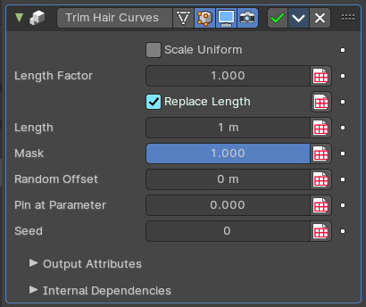
Trim Hair Curves
Trims or scales hair curves to a certain length.

Scale Uniform
Scale each curve uniformly to reach the target length.

Length Factor
Multiply the original length by a factor

Replace Length
Use the length input to fully replace the original length.

Length
Target length for the operation.

Mask
Mask to blend overall effect.

Random Offset
Trim hair curves randomly up to a certain amount.

Pin at parameter
Pin each curve at a certain point for the operation.

Seed
Random seed for the operation.

Output

Geometry
The output geometry.

